Handling Tasks on Raspberry Pi Which is Generated By Keyboard Interrupts in x86

Project Purpose:
The purpose of this project is to create a system where a Raspberry Pi acts as the client that receives a keyboard interrupt from an x86-based server. Upon receiving the interrupt, the Raspberry Pi will execute a specific task, such as triggering a GPIO action or performing other operations. This project aims to demonstrate the interaction between two systems (x86 and Raspberry Pi) through hardware interrupts and communication protocols, focusing on cross-platform integration, event-triggered automation, and socket communication.
Functionalities of the Client (Raspberry Pi):
Socket Client Setup:
- The Raspberry Pi sets up a socket client to connect to the server running on the x86-based machine.
- It listens for incoming messages from the server and waits for instructions based on the interrupts triggered by the server.
Receiving Interrupt Information:
- When the Enter key is pressed on the x86-based system, it triggers an interrupt. The interrupt handler on the server side sends a message to the Raspberry Pi via the socket connection.
Processing the Interrupt:
- The Raspberry Pi receives the message (indicating the interrupt) and processes it. This could involve triggering a GPIO pin or performing other specific actions based on the message content.
Executing Tasks:
- Upon receiving the interrupt signal, the Raspberry Pi can initiate a task. For example, it might blink an LED, send a signal to another device, or execute a script based on the message received from the server.

Operating Environment:
- Role: Client (Raspberry Pi)
- Operating System: Raspbian or other Linux-based distributions for Raspberry Pi
- Platform: Raspberry Pi 4B (or similar)
- Network Protocol: TCP (for reliable communication)

Block Diagram:

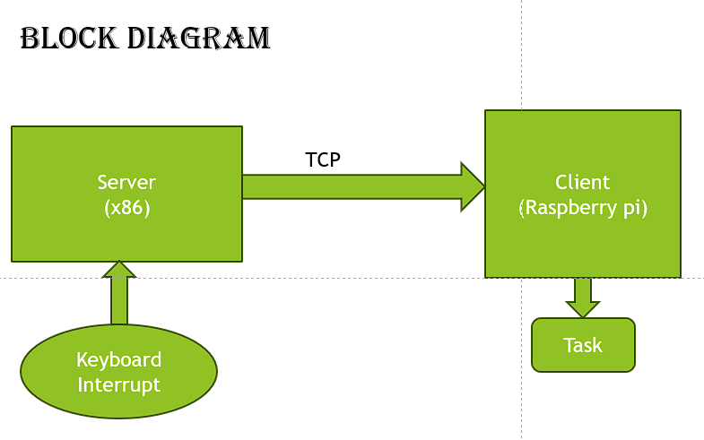

Flowchart :

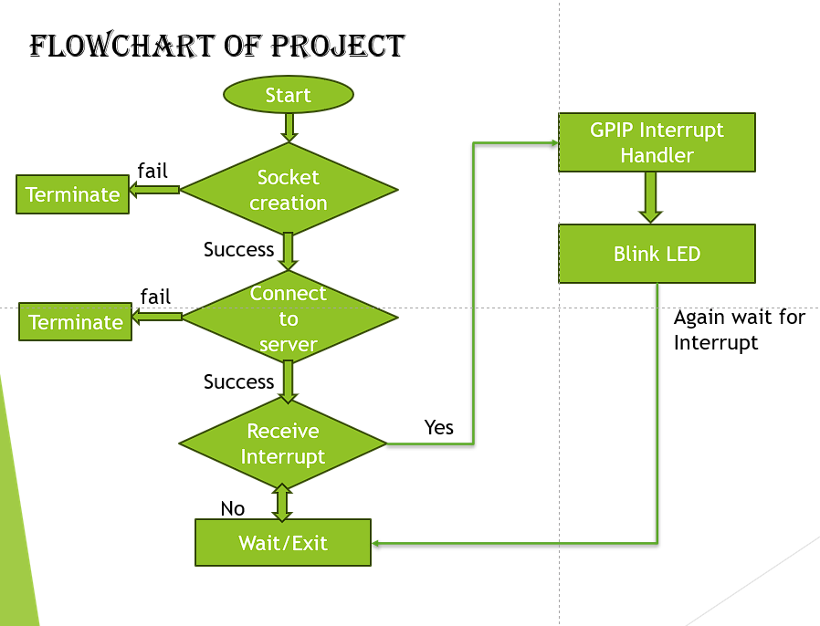

Socket Communication (Raspberry Pi):
- Setup Socket Connection: The Raspberry Pi establishes a socket connection to the server using standard socket() and connect() calls.
- Receive Interrupt Data: The Raspberry Pi reads the incoming messages indicating interrupt events (e.g., from the server).
- Process Interrupt: Based on the received message (like "Enter key pressed"), the Raspberry Pi triggers a task (such as a GPIO action).

Conclusion:
In this project, the Raspberry Pi acts as the client that receives an interrupt signal from the server (running on an x86-based system). Upon receiving this signal, the Raspberry Pi performs specific tasks based on the event. Using a TCP socket connection, the communication is established between the x86 server and the Raspberry Pi. This system enables real-time event handling, where the Raspberry Pi performs actions triggered by the server’s keyboard interrupts.

